Computer Language Coding Concepts

Value Get & Set in a Diagram
The concept of value Get and Set is explained in the article Value Get & Set. The current article demonstrates their expression in a diagram.

The system members Value . Get and Value . Set are part of the system interface of a related item or a related list item and displayed in a diagram as follows:

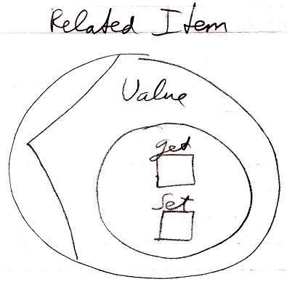

See also: System Objects, Value Get & Set

Author & Copyright: Jan-Joost van Zon Date: July 18, 2008 – July 18, 2008 Location: Oosterhout, The Netherlands Status: Finished

